WEEK 8:
SYSTEM TESTING AND DEPLOYMENT PREPARATION

Balisacan, Mark Justin F.
Binuya, John Lloyd A.
Reyes, Allysa B.

WEEK 8: SYSTEM TESTING AND DEPLOYMENT PREPARATION

I. INTENDED LEARNING OUTCOME (ILO)
At the end of this laboratory activity, students should be able to:
Conduct comprehensive system testing and user acceptance testing (UAT), evaluate system readiness based on user feedback, prepare the deployment environment, and produce a Beta Version of the system ready for agency immersion and deployment.

II. PERFORMANCE TASK
Following system enhancement and debugging activities conducted in Week 7, your team shall conduct formal System Testing and User Acceptance Testing (UAT) using representative users from the client organization.
The results of testing will determine whether the system is ready to transition from an Enhanced Prototype to a Beta Version for deployment and agency immersion.

III. WEEK 8 ACTIVITIES
Activity 1 – System Testing Preparation
Activity 2 – System Testing Execution
Activity 3 – User Acceptance Testing (UAT)
Activity 4 – UAT Result Analysis
Activity 5 – Deployment Environment Preparation
Activity 6 – Deployment Checklist Validation
Activity 7 – Adviser Validation

ACTIVITY 1
SYSTEM TESTING PREPARATION

Purpose
To ensure that all testing activities are properly planned and documented before execution.

Procedure
- Review completed modules and system functionalities.
- Prepare test scenarios and test cases.
- Identify participants for UAT.
- Prepare testing environment.
- Complete Form 1.

FORM 1
SYSTEM TESTING PLAN
Directions
List all functionalities to be tested.
No. | Functionality | Test Scenario | Expected Result
1 | User Authentication | Log in using valid and invalid credentials. | User successfully logs in with valid credentials, while invalid credentials display an error message.
2 | Lineman Module | View assigned reports and update report status. | Lineman can view assigned reports and successfully update report progress.
3 | Resident Module | Submit a report with a photo and location and view report history. | Report is submitted with required details, and the resident can view submitted reports.
4 | Report Receiving Schedule | Submit a report during working hours. | Report is received by the system according to the schedule.
5 | Notification System | Receive a notification for an assigned report. | User receives an assignment notification successfully.
6 | Admin Dashboard | View dashboard information. | Dashboard displays relevant system information.
7 | Incident Module | Create an incident report. | Incident report is recorded in the system.
8 | Resident Delete Report | Delete a pending report. | Pending report is deleted successfully.
9 | Error Message: Internet Connection | Perform an action without an internet connection. | System displays an internet connection error message.
10 | Account Active Status | Check account status. | Account status is displayed correctly.
11 | Survey / Ratings | Submit a service rating. | Rating is successfully recorded.
12 | Valid ID User Authentication | Register using a valid ID and selfie. | Registration proceeds after verification.
13 | Report Verification | View report details before verification. | Administrator can review and verify reports.
14 | Forgot Password | Reset password using the recovery process. | User can successfully reset their password.
15 | Account Banning | Ban a user account. | Account access is restricted.
16 | Report Progress Tracker | Track report status updates. | Report progress is displayed and updated correctly.
17 | Map View | View reports on the map. | Reports appear at their mapped locations.
18 | Lineman Monitoring | View lineman availability and status. | Lineman status is displayed correctly.
19 | Power Advisory | Filter advisories by municipality. | Advisories are filtered according to the selected municipality.
20 | Analytics | View average response time per branch and team. | Response time statistics are displayed correctly.

Testing Team

No. | Member | Responsibility
1 | Mark Justin F. Balisacan | Conduct system testing and verify web functionalities.
2 | John Lloyd A. Binuya | Conduct system testing and verify mobile functionalities.
3 | Allysa B. Reyes | Document test results and prepare testing reports.

UAT Participants

No. | Name | Position/Role
1
2
3
4
5
6
7
8
9
10
11
12
13
14
15
16
17
18
19
20
21
22
23
24
25
26
27
28
29
30
31
32
33
34
35
36
37
38
39
40
41
42
43
44
45

Prepared by: Allysa B. Reyes

Testing Lead

ACTIVITY 3
USER ACCEPTANCE TESTING (UAT)

Purpose
To determine whether the system satisfies user requirements and expectations.

Procedure
- Orient users regarding the system.
- Allow users to perform assigned tasks.
- Observe user interaction.
- Distribute evaluation forms.
- Collect completed forms.
- Complete Forms 3 and 4.

FORM 3
USER ACCEPTANCE TESTING ATTENDANCE SHEET

Directions
All participants must sign after completing testing activities.

Project Title: ISELCONNECT: A Power Outage and Visual Maintenance Reporting System

Date: September , 2026

No. | Name | Position | Signature
1
2
3
4
5
6
7
8
9
10
11
12
13
14
15
16
17
18
19
20
21
22
23
24

No. | Name | Position | Signature
25
26
27
28
29
30
31
32
33
34
35
36
37
38
39
40
41
42
43
44
45

ACTIVITY 5
DEPLOYMENT ENVIRONMENT PREPARATION

Purpose
To prepare hardware, software, database, and user resources needed for deployment.

Procedure
- Verify hardware requirements.
- Verify software requirements.
- Prepare installation files.
- Prepare database backup.
- Prepare user accounts.
- Complete Form 6.

FORM 6
DEPLOYMENT ENVIRONMENT PREPARATION REPORT

Directions
Document all deployment resources.
Hardware Requirements
Resource | Available
Computer/Server | □
Network Connection | □
Storage Device | □

Software Requirements
Software | Available
Operating System | □
Database Management System | □
Runtime Environment | □
Application Software | □

Deployment Resources
□ Installation Package Prepared
□ Database Backup Created
□ User Accounts Prepared
□ Administrator Account Prepared

ACTIVITY 6
DEPLOYMENT CHECKLIST VALIDATION

Purpose
To verify readiness for agency immersion and deployment.

Procedure
- Review deployment requirements.
- Verify deployment resources.
- Verify documentation.
- Confirm Beta Version readiness.
- Complete Form 7.

FORM 7
DEPLOYMENT CHECKLIST

Directions
Check all items completed before deployment.

System Readiness
□ Beta Version Completed
□ All Critical Bugs Resolved
□ UAT Completed
□ UAT Results Acceptable

Technical Readiness
□ Database Ready
□ Installation Package Ready
□ Backup Files Available
□ User Accounts Configured

Documentation Readiness
□ User Manual Prepared
□ Technical Documentation Updated
□ Installation Guide Prepared

Deployment Approval
□ Ready for Agency Immersion
□ Requires Additional Preparation
Remarks:

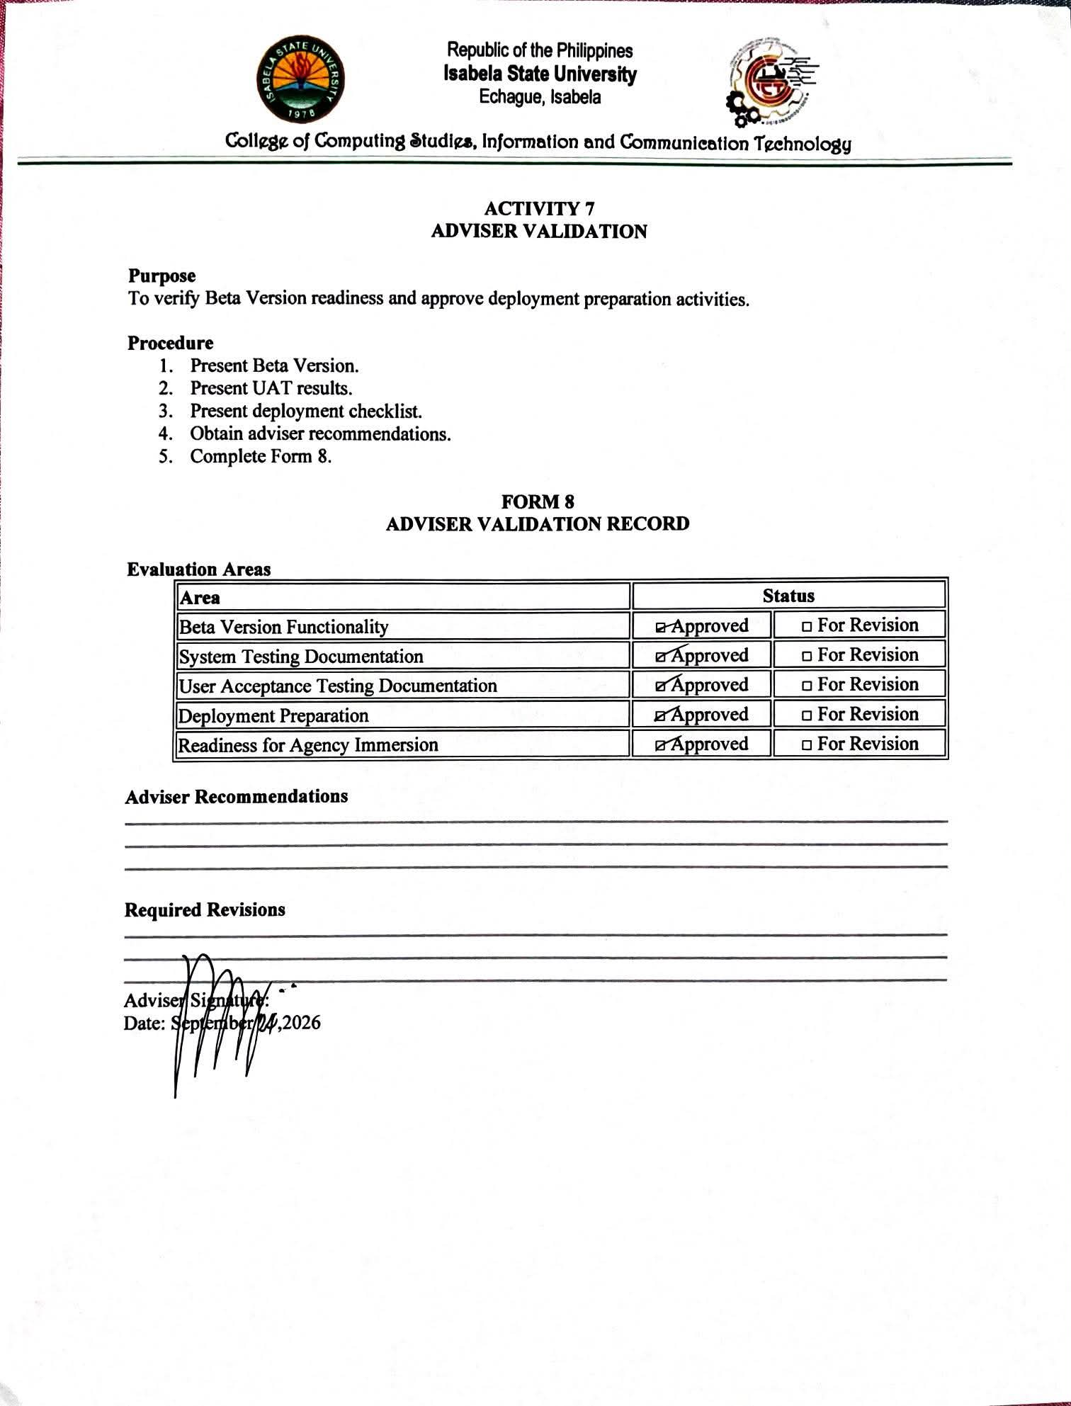
V. REQUIRED WEEK 8 SUBMISSION
- Form 1 – System Testing Plan
- Form 2 – System Testing Report
- Form 3 – UAT Attendance Sheet
- Form 4 – UAT Evaluation Forms
- Form 5 – UAT Summary Report
- Form 6 – Deployment Environment Preparation Report
- Form 7 – Deployment Checklist
- Form 8 – Adviser Validation Record
- Beta Version Source Code
- Testing Evidence and Screenshots

VI. WEEK 8 DELIVERABLES
✓ Beta Version
✓ User Acceptance Testing Report
✓ Deployment Checklist
✓ System Testing Documentation
✓ UAT Evaluation Results

These outputs provide evidence that the project has successfully passed formal testing and user validation and is ready for Week 9 Agency Immersion and Actual Deployment Activities.

